NOTICE OF ANNUAL GENERAL MEETING

Notice is hereby given that the 2018 Annual General Meeting of the Forest and Rural Fire Association of New Zealand will take place as follows:

Date: Friday 16 November

Start time: 1445hrs

Venue: Intercontinental Hotel Wellington
2 Grey Street
Wellington 6011

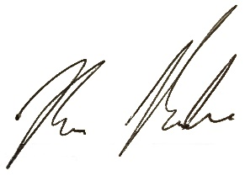
Kevin Ihaka
FRFANZ Management Committee Chair

