TO: All Members of the Forest and Rural Fire Association of New Zealand

FROM: Kevin Ihaka
FRFANZ Management Committee Chair

DATE: 12 October 2018

SUBJECT: UFBA/FRFANZ CONFERENCE – 16-18 November 2018, Wellington

Please find enclosed:
- Notice of Annual General Meeting
- Conference Order of Business Paper
- AGM Minutes held 2 August 2017
- 2017/2018 Financials
- FRFANZ Constitution
- FRFANZ Officer Nomination Forms

NOMINATION FORMS
An essential part of Conference is to select the FRFANZ Officers that your fire force wishes to represent them. Please

OBITUARIES
Please ensure you advise the UFBA Office of those members of your Fire force that have passed away since the last Conference that were either serving or retired at the time of their death. Please contact Megan Leggett at the UFBA Office (megan@ufba.org.nz) as soon as possible with the following information in order for their names to be acknowledged at the Conference:
- Full Name
- Last fire force they were members of
- Last know rank in that fire force

DRESS CODE
The dress code is:

Day One (Friday): Collared shirt and dress pants/skirt (FENZ Rural shirt if preferred)

Welcome Dinner: Smart casual

Day Two (Saturday): Collared shirt and dress pants/skirt (FENZ Rural shirt if preferred)

Conference Dinner: Semi-Formal (no jeans)

On behalf of the Forest and Rural Association of New Zealand, we look forward to seeing you in Wellington.

Kind regards

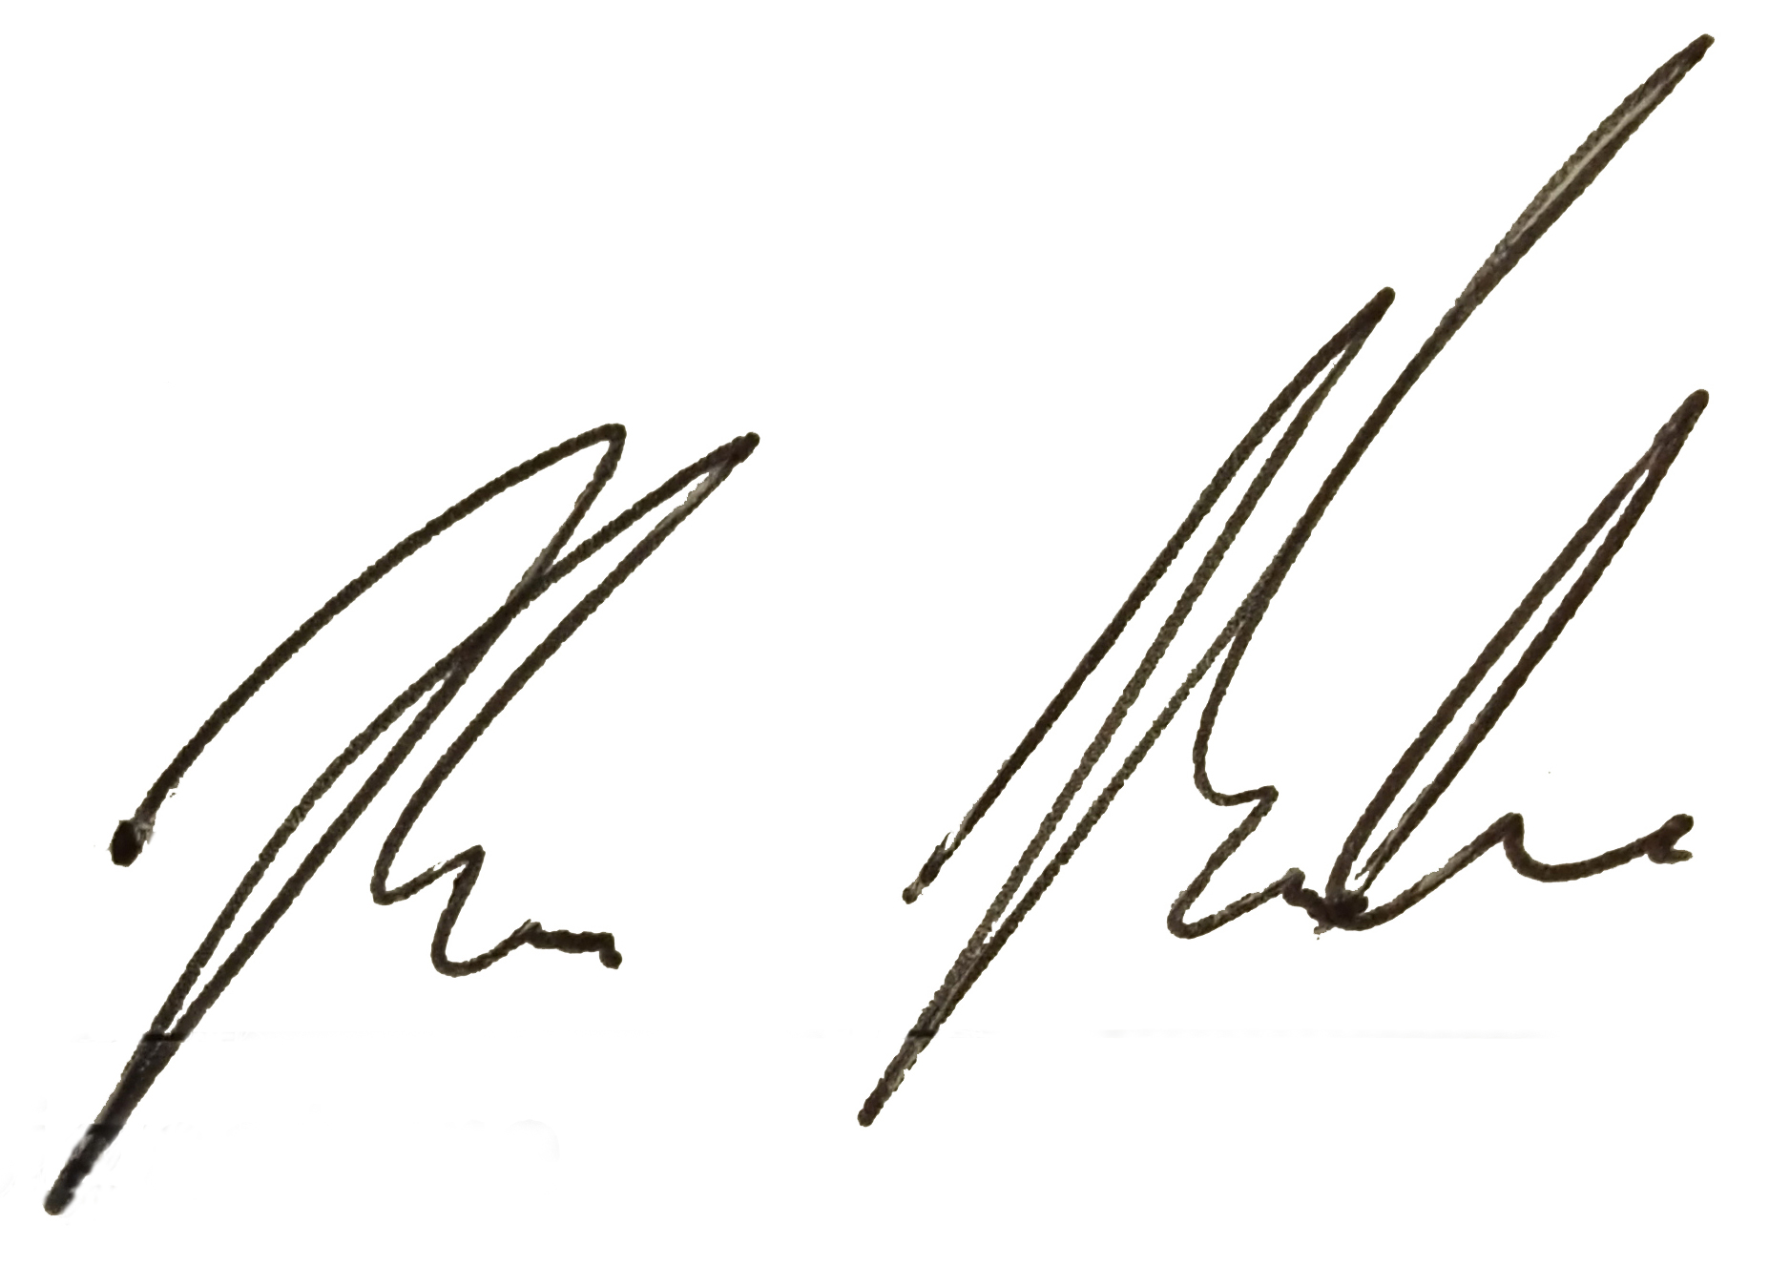
Kevin Ihaka
FRFANZ Management Committee Chair

